**Spa & Yoga**

1. **Hollis Well Center**

**Massage Therapy Menu**

## **SOMATO AWARENESS SYSTEM**

Our signature massage is a combination of effective body work including deep tissue, craniosacral therapy, Thai massage and holistic aromatherapy designed by Holis Wellness Founder, Evelina Bolognini.

Results in:

* Deep muscle release
* Improved joint mobility
* Nervous system reset
* Detox system optimised
* Profound relaxation
* Body Awareness

Proven to offer effective relief from lumbar pain, migraine and related symptoms, stiffness and joint restriction, sense of heaviness, anxiety and shortness of breath.

90-Minute $130.00 | 2-Hour $175.00

## **HOLISYNERGIE**

Our highly trained therapists create a specialized session to meet your individual needs. We combine techniques including Sweedish Massage, Deep Tissue, Reflexology, and more. Holisynergie is a unforgettable experience for your whole being.

45-Minute $70.00 | 60-Minute $85.00 ($150 Couple) | 90-Minute $110.00 ($200 Couple)

## **PURE BLISS**

This incredibly relaxing Swedish Massage uses light to medium pressure incorporating long, soothing, and fluid strokes to stimulate blood flow, oxygenation, and circulation to the tissues.

60-Minute $75.00 | 90-Minute $100.00

## **TRADITIONAL THAI – *Asokananda Tradition***

This ancient massage practice from Thailand uses acupressure points and passive stretching to give your body profound relaxation, increased flexibility and energy. Please wear comfortable clothing.

90-Minute $115.00

## **TRADITIONAL CUPPING SESSION**

During a cupping session, different sizes of cups are applied along each side of your spine and on the areas you may need to treat. The gentle suction produced in the cups will be used to decongest the tissues. The result is an immediate sense of relief from pain tension and an overall sensation of lightness.

60-Minute $75.00

## **HOLIS JUMPSTART SYSTEM**

*Craneo Sacral, Cupping & Aromatouch Technique*We’ve designed this powerful combination of treatments with the intention to offer an effective jump start for your health and well-being. Craneo Sacral Therapy has a tuning effect over the nervous system, cupping adds a detoxifying element, while Aromatherapy will address and rebalance any energetic stagnation. Addressing your whole system from different angles will support the recovery from any kind of health issue and give a boost to the immune system and overall energy.

60-Minute $110.00

## **REFLEXOLOGY**

This healing art is a highly effective method used to restore and maintain natural equilibrium in the body. Working primarily with the pressure points on the feet, hands, and ears. This treatment has a powerful detoxifying effect that also encourages the Chi (life energy) to flow, promoting overall health and healing. An amazing grounding experience for travelers.

60-Minute $85.00 | 45-Minute $65.00

**Listed prices do not include mandatory 13% IVA tax.**

# 

# 

# 

# 

# **Spa Package Menu**

PLEASE NOTE: All times for Spa Packages are estimates and may vary as some packages may take a bit longer or finish sooner. Listed prices do not include mandatory 13% IVA tax.

## **DETOX SYSTEM**

A very effective way to detoxify while decompressing and improving your body functions and skin texture:

* HOLISYNERGIE Massage
* MUDDY BUDDY Body treatment
* ESSENTHYA Facial

2-Hour $165.00

## **PURA VIDA**

Warm breeze, lush surroundings, and a great spa treatment…pure pampering Costa Rica style!

* ESSENTHYA MINI Facial
* PURE BLISS Massage (60-Min)
* Choice of: HOLIS SPA Manicure or Pedicure

2-Hour $150.00

## **REFRESH**

Sun exposure and outdoor activity can drain your body of minerals and energy. We have created a specific combination of therapies aimed to restore and refresh your body and skin:

* ALOE MINT SMOOTHIE Body Treatment
* ESSENTHYA Facial
* HOLIS SPA Manicure

2.5-Hour $190.00

## **HEAD-TO-TOE BLISS**

Pure decadence … We will pamper you with a delightful combination of:

* CHOCOMOKACOCO Body Treatment
* PURE BLISS Massage (90-Min)
* ESSENTHYA Mini Facial
* HOLIS SPA Pedicure

3-Hour $250.00

## **LET’S PARTY**

Share and unforgettable experience with friends and family in the privacy and comfort of your own space:

* ESSENTHYA Facial
* HOLISYNERGIE Massage (60-Min)
* Choice of: Body Treatment
* HOLIS SPA Manicure & Pedicure

3.5-Hour $250.00

## **THAI HEAVEN**

Thai massage encompasses our whole being by working on our muscles, skeleton, and the internal energy within our body. This exotic package is the total workout and re connection that our body, mind, and soul are so often seeking:

* ESSENTHYA MINI Facial
* THAI Massage
* HOLIS SPA Pedicure

2.5-Hour $210.00

## **SHARE THE MAGIC**

This duo package caters to the couple seeking quality time together in an intimate setting

* PURE BLISS Couple Massage (90-Min)
* CHOCOMOKACOCO Body Treatment
* HOLIS SPA Pedicure

3.5-Hour $450.00/couple

# **Organic Facials Menu**

Please Note: Listed prices do not include mandatory 13% IVA tax.

## **ESSENTHYA HYDRATION**

Rehydrate your skin with vital nutrients, reducing damage from sunburn, windburn, and other free radicals. Effective in reducing redness, hydrate and balance your skin while cleansing your pores of sunscreen residue. Includes a cooling peppermint foot massage.

60-Minute $60.00

## **ESSENTHYA DELUXE**

A customized blend of organic, nourishing products will balance, heal, and beautify your skin using a synergistic 6 step treatment. Included is our signature neck and face massage that will increase blood flow and oxygen while enhancing active ingredient absorption.

75-Minute $75.00

## **ESSENTHYA MINI-FACIAL**

Refresh and invigorate your skin after a day of activity in the tropics with the mini version of our signature facial.

45-Minute $45.00

# **Body Treatments Menu**

Please Note: Listed prices do not include mandatory 13% IVA tax.

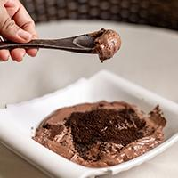

## **CHOCOMOKACOCO**

This delicious fragrant body wrap will firm and tone your skin with the slimming properties of caffeine. Sooth your body and senses in chocolate moka heaven and our organic honey facial mask. This sexy treatment is a great energy booster.

60-Minute $75.00

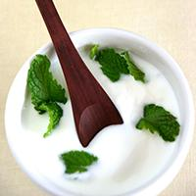

## **ALOE MINT SMOOTHIE**

Quench dry skin with our hydrating sun repair wrap. Freshly harvested aloe, cucumber, chamomile, and mint are combined with the healing properties of seaweed followed by an application of our aloe mint serum. Great for sunburn!

60-Minute $85.00

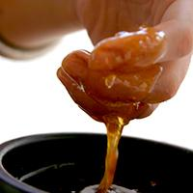

## **SPICY GINGER RUB**

This detoxifying wrap uses the natural anti-inflammatory properties of fresh ginger root with soothing organic raw honey to stimulate your immune system, ease tension in sore muscles, and nourish dry skin.

60-Minute $75.00

## **MUDDY BUDDY**

Remineralize, cleanse, and tone with the indigenous Thermal Mud sourced from the base of Costa Rica’s Arenal volcano. This wrap offers you the synergistic effect of thermal mud infused with eucalyptus to draw out toxins, enhance immunity, and give your spirit a boost.

60-Minute $85.00

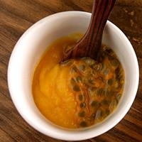

## **TROPICAL ENZYME POLISH**

Fresh, delicate, and very effective, this body wrap gently polishes using tropical fruit enzymes infused with vitamin C to reveal healthier looking skin. Recommended for delicate skin!

60-Minute $75.00

## **SLIMMING KELP COCCOON**

Our slimming kelp seaweed wrap combined with grapefruit and lemon provides restoring qualities, visibly reduces puffiness, slims and tones the skin, and increases metabolism.

60-Minute $85.00

# **Manicure & Pedicure Menu**

Please Note: Listed prices do not include mandatory 13% IVA tax. Additional charges apply for acrylic and gel removal on hands or feet $10 per service.

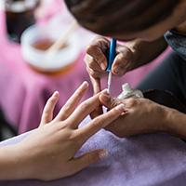

## 

## **HOLIS SPA MANICURE**

Leave your hands… in our hands. Your Basic Manicure combined with a heavenly hand treatment, which includes exfoliation and massage. Your hands will never be softer or smoother.

45-Minute $35.00

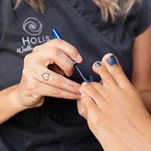

## **HOLIS SPA PEDICURE**

Put your feet up and relax! Pedicure with an Aromatic Sea Salt foot soak, exfoliation of feet and lower legs, and a deeply relaxing massage with our Cooling Peppermint Gel. Ahhh!

60-Minute $45.00

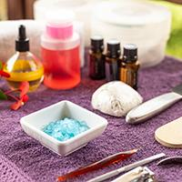

## **HOLIS SPA MANICURE & PEDICURE COMBO**

Get the best of both worlds and let us pamper both your hands and your feet!

60-Minute $65.00

## **MINT BLAST LEGS & FEET**

Hot, tired, stressed legs and feet will welcome the relief... After an invigorating massage with the cooling essence of Peppermint Gel and a gentle Dry Brush, your legs and feet will be wrapped with our exclusive Aloe Cooling Musse, perfect after a day of activities in our tropical paradise. Included is an ultra relaxing Scalp Massage.

50-Minute $55.00

## **MEN’S MANICURE**

It looks good and feels better. Included are: cleansing, shaping, cuticle work, nail buffing, and a delicious hand massage.

30-Minute $25.00

## **MEN’S PEDICURE**

Enjoy our HOLIS SPA PEDICURE designed for men with an extra long foot massage to unwind and relax.

60-Minute $35.00

Yoga

# **Yoga Classes**

## **DROP-IN STUDIO CLASSES**

$20.00 per person (60-Min or 90-Min Class) + Taxes

Send us an email with questions about drop-in classes here or send us a message on [WhatsApp](https://wa.me/50688146760) to let us know you’re coming!

## **PRIVATE CLASSES**

Private classes are 60-min in length and can be done at Holis Wellness Center in Manuel Antonio or at your location, transportation included!

* One on One Classes: $65
* Couples Classes: $40 each person
* Group Classes: $20 each (Minimum 4 people)

Listed prices do not include mandatory 13% IVA tax.

## **VINYASA YOGA Manuel Antonio**

A flowing set of postures linked together by the breath, with a strong focus on proper alignment. Through a creative sequence of poses that challenge the body and focus the mind, you will create both strength and flexibility. You will leave this class feeling strong, centered and rejuvenated. This is a well-balanced, active practice, appropriate for all levels with opportunities to go deeper for more advanced students as well as modifications for those just starting out or recovering from an injury.

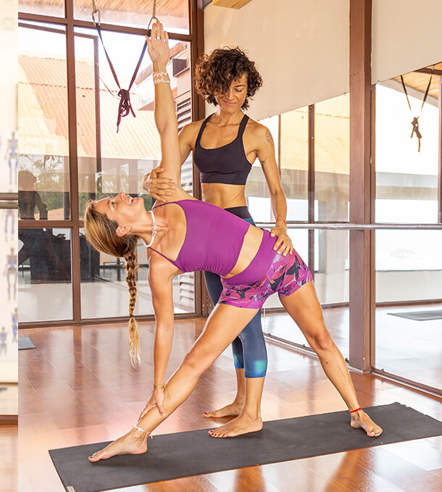

## **HATHA YOGA Manuel Antonio**

This class includes the practice of asanas (yoga postures) and pranayama (yoga breathing exercises), which will help bring peace to the mind and body. This class may include forward bends, backward bends, spinal twists, inversions and sun or moon salutations. Join us to increase flexibility of the spine, strengthen bones and stimulated the circulatory and immune systems. This class is suitable for all levels and is a great introduction to yoga for new students.

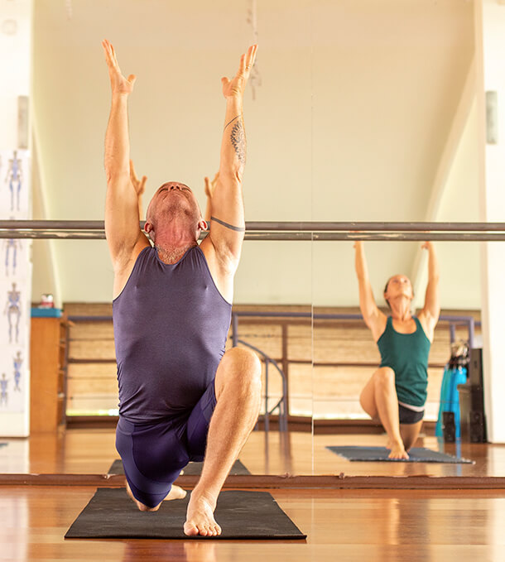

## **POWER FLOW YOGA Manuel Antonio**

A Vinyasa style, one hour yoga class that focuses on balance, proper body alignment, breathing, and energizing postures that deeply connect the mind and body. Creating strength and flexibility through movement.

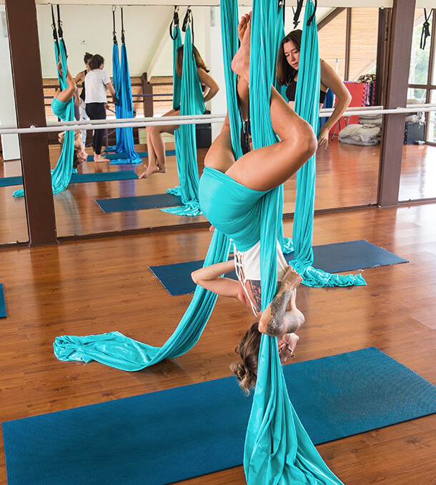

## **AERIAL YOGA Manuel Antonio**

In our Aerial Yoga classes you will surprise your body & mind with something new and fun. Experience Zero-Compression Inversions that definitely relieve back pain by creating space between your vertebral discs for the nerves of your spinal cord to be loose. You will hydrate soft tissues that help relieve back pain as well. Increase your brain’s “powergive” to rebirth your brain cells as you release neurotransmitters through inversion therapy.

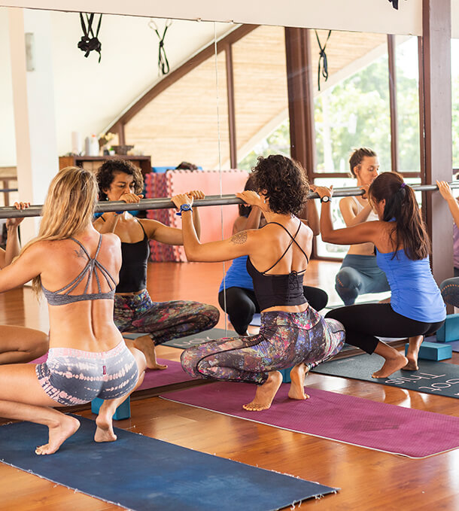

## **YOGA FIT FUSION**

Let’s build heat (sweat out those toxins!) and stretch, strengthen and tone our bodies! We will draw on traditional yoga postures and movement with breath while also incorporating light weights and repetition to strengthen and tone the whole body … and even get our heart rate up a bit. Modifications are offered to provide students plenty of options to either increase intensity or take it down a notch, making this yoga fitness fusion class a great option for everyone.

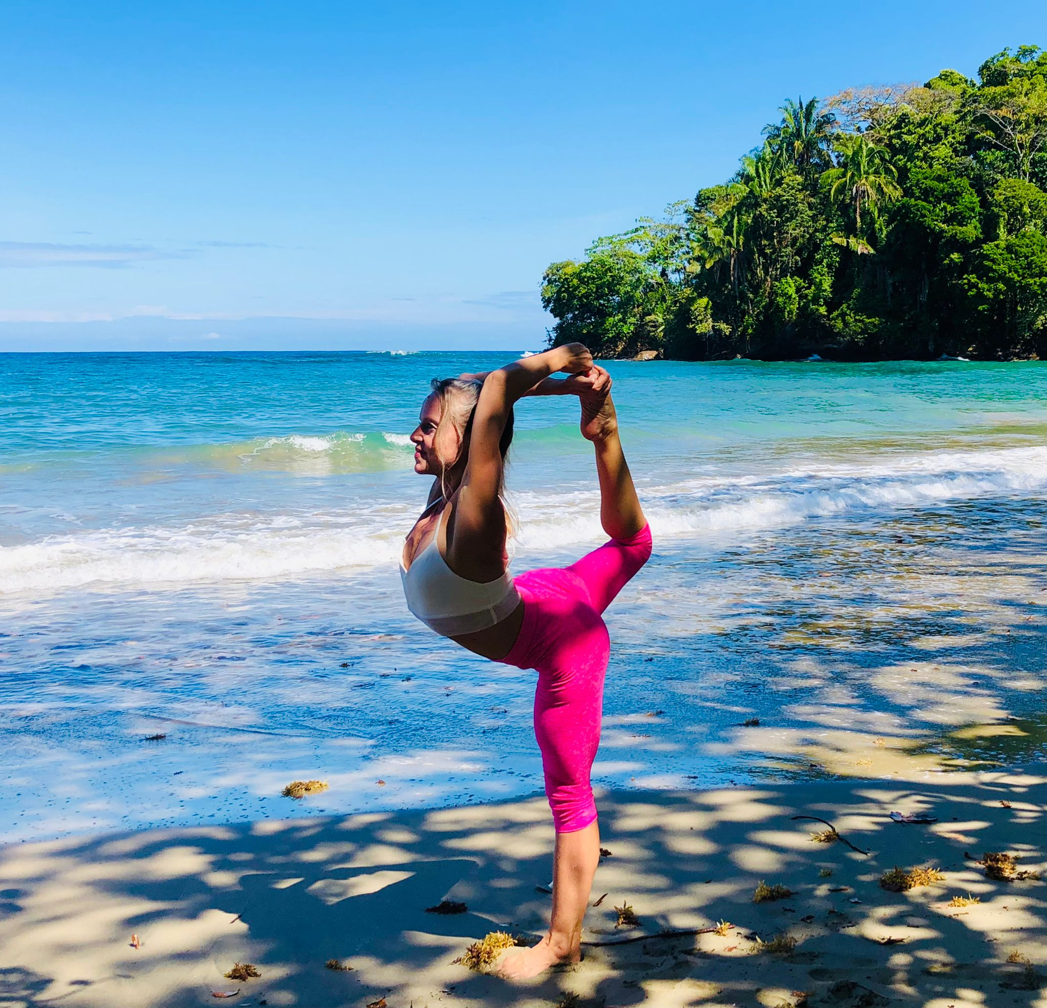

## **Vinyasa Tantra Yoga**

Vinyasa Tantra is a series of creative namaskars, sequenced and choreographed to music. Classical asanas are guided by the rhythm of the breath, creating a tandava, an elegant dance of breath and movement. I design each class with a balance of alignment, yoga aids, form, and flow; pranayama, yoga philosophy, and meditation. We expand with energy through the body, gently returning to an inner space of stillness and serenity. Our classes are uniquely themed, inspired by nature, ancient Indian philosophy, and classical yoga texts.

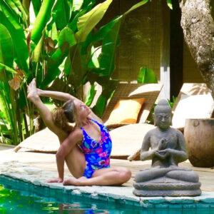

## **Dharma Yoga**

Dharma Yoga is a classical yet contemporary expression of Hatha-Raja Yoga, deeply rooted in Indian philosophy, yoga tradition, and ahimsa, universal compassion. This graceful and moving sadhana integrates elements of dynamic Vinyasa and Hatha Yoga, incorporating beautiful backbends, light inversions, and arm balances. Pranayama (breath awareness), dharana (concentration), dhyana (meditation), and yoga nidra (healing relaxation) are integral aspects of this practice. Dharma Yoga is a dynamic sadhana that cultivates radiant health, a peaceful mind, a compassionate heart, and a sattvic soul.

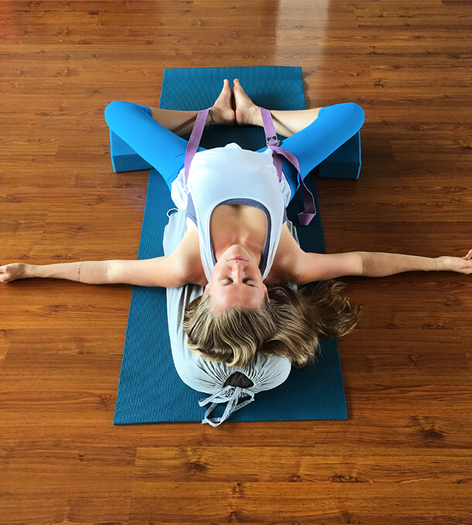

## **SLOW FLOW YOGA**

You will find elements of Self Awakening Yoga in this slow flow class. Somatic awareness and movement meditations take you on a journey inwards. Surrender to your true nature.

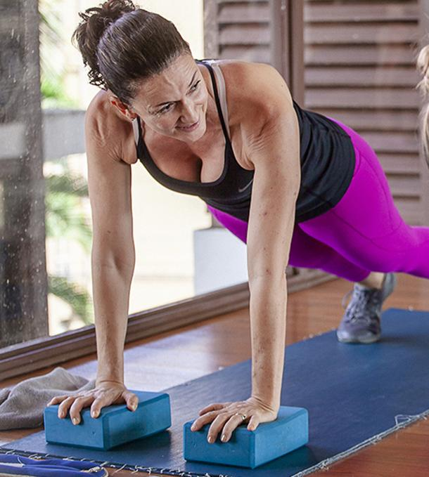

## **FUNCTIONAL BALANCE**

The class works on strength, balance, core, and deep-tissue stretching, which will be 90 minutes and consists of 2 parts: 45 minutes will be with Lara on the balance board and 45 minutes will be with Evelina. During this class, you will learn how to find and practice balancing on a balancing board. Curious to learn more? Come try it out! All levels are welcome.

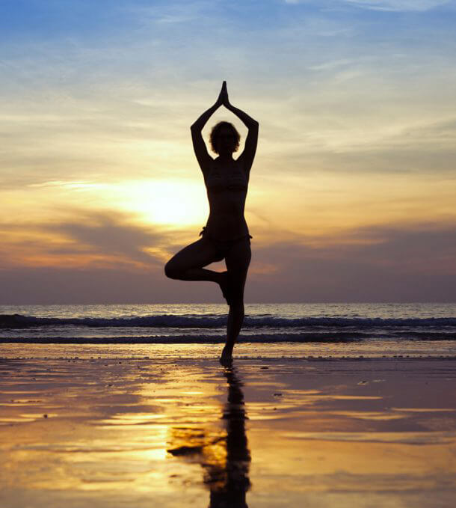

## **Kundaluna Yoga**

Just like the tides, we are deeply connected to the moon and her cycles. The intention and focus of each Kundaluna class will reflect the lunar energies of that day. This class was created by Kerri to be a powerful practice of Asana & Meditation inspired by Kundalini yoga and breathing techniques, beautifully aligning with nature, and holding space for the magical transformations that yoga facilitates.

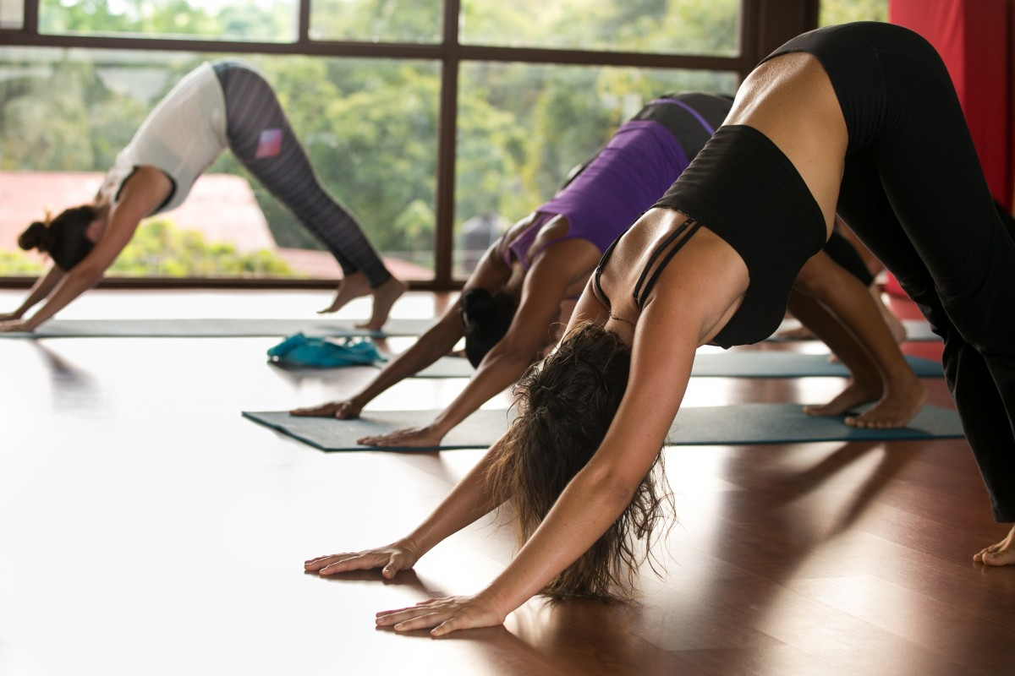

## **YOGA FIT ASANAS**

This class is based on yoga stretching and functional exercises. Always incorporating breathing exercises, it’s focused on strengthening the whole body and weights will be used for different movements. We will finish with Yoga’s most important asana, Shavasana. This class will be guided mostly in Spanish.

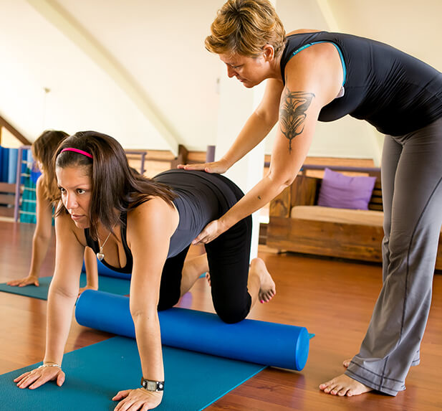

## **GYROKINESIS®**

The Gyrokinesis Method is a movement method that addresses the entire body, opening energy pathways, stimulating the nervous system, increasing range of motion, and creating functional strength through rhythmic, flowing movement sequences. It is an original and unique method, which coordinates movement, breath, and mental focus.

1. **Plumeria spa**

**Relaxation and rejuvenation await at Plumeria Spa, the Tulemar Resort Hotel’s beautiful new facility.**

**Enjoy treatments in our spa, or if preferred, one of our therapists will come right to your unit. Our clients love this service!  
See the many options we have to offer in our spa menu, as well as details of our daily specials.**

### **Spa Treatments**

### **Pedicure & Manicure**

### **Pedicure: $55 Manicure: $45 Semi-Permanent Enameling: $25**

### 

### 

**Facials**

**Mini Facial: $45/30min  
Deep Cleaning Facial: $100/80min  
Hydrating Facial: $80/50min  
Anti-Age Facial: $110/90min  
Gentlemen’s Facial: $90/60min**

### **Hands & Feet**

### **Kids Menu**

**Kids Massage: $50/30min  
Feet, Head, Hands Massage: $40/30min  
Burn Avocado Honey Wrap: $50/30min**

### **Scrubs**

**$75/60min**

**Volcanic Lava  
Sea Salts & Coconut Milk  
Rose Petals & Lavender  
Tamarind**

### **Wraps**

**$85/60min**

**Coffee  
Lavender Flowers  
Gooseberry Papaya  
Avocado & Green tea**

### **Massages**

**Plumeria Massage: $100/80min  
Couples Massage Special: $200/90min  
Relaxing Massage: $85/60min $110/90min  
Lavander Massage: $85/60min $110/90min  
Coffee Massage: $85 /60min $110/90min  
Deep tissue Massage: $95/60min $120/90min  
Aromatherapy: $85/60min $110/90min  
Bamboo Massage: $90/60min  
Hot Stones: $120/90min  
Cold Stones: $90/60min  
Prenatal Massage: $80/60min  
Back, Neck and Shoulder: $50/40min  
Head, Hands, and Feet: $40/30min  
Tired Feet Massage: $40/30min  
Facial Massage: $40/30min**

### **Special Packages**

**$200/150min**

**Tropical Fusion  
*Tamarind exfoliation, cape gooseberry and  
papaya wrap finishing with a relaxing massage  
and passion fruit cream.***

**Mother Earth  
*60min hot stone massage, lavender flower wrap  
and hydrating mini facial.***

**Plumeria Experience  
*Bamboo massage, exfoliation of sea salts and  
coconut milk and scalp massage treatment.***

**All reservations cancelled less than 24 hours prior to the scheduled treatment will have a penalty  
of 50% of the total cost of booked services. For any further information please contact your concierge   
*\*Prices do not include 13%***

1. **Rain Drop spa**

**In the spirit of feng shui and influenced by Asian architecture, our spa is a beautiful sanctuary that will make you feel like you’ve entered a temple in the rain forest. Our team, conformed by certified massage therapists and spa specialists, carries a sense of gratitude and of taking care of others. Extensive research from many disciplines has gone into our treatments to provide you with the best possible spa experience.**

**Manager Martha Chinchilla**

**Vichy Shower**

**Aromatic Body Scrub & Back And Shoulder**

**60 min / $70**

Massage Pamper yourself with this exquisite body scrub, deep, yet gentle, exfoliating treatment with raw organic sea salts blended with Aromatic oils, conserves vitamins, minerals, from natural extract. It removes dead skin cells and impurities off the skin. Continued with our back and shoulder massage finishing this blissfulness with the Vichy Shower

**Indonesian Ginger body scrub & reflexology**

**60 min / $80**

**Enjoy ancient treatment acupressure to all the reflex points on your feet, promotes health and balance throughout your body. Continued with an aromatic ginger scrub blended of different spices. This treatment has the ability to detoxify as well as warm and energize the body. Feel a sense of renewal with Vichy shower.**

**Coconut Aloe Body Wrap & Scalp Massage**

**Sunburn Treatment**

**60 min / $80**

This amazing Sunburn treatment has an Ayurveda medicine coconut is use to pacify pitta. The combination of Aloe Vera and Coconut we created a remedial recipe for skin irritants and sunburn. Your skin will feel cooled, soothed and moisturized followed by acupressure scalp massage to restore body energy and balance.

To finish nurturing body and mind with the Vichy shower.

**Raindrop Massage**

50 min / $90

This exotic massage combines the element of water and hand therapy, stimulates the chakra points, revitalize circulation. Releases blocked energies from your body, calms the nervous system, promotes spirituality and nurturing the body and mind into a bliss.

**Chocolate Therapy**

95 min / $130

Pamper yourself with wonderful Chocolate Therapy treatment, melt away your stress with Swedish massage, recommended to release muscular tension. Also promotes health and balance to your body. Continue this essence treatment with a chocolate wrap rich in vitamin C and B12. To finish this amusing therapy you’ll have 15 minutes of the Vichy Shower.

**Body Therapies**

**Back And Shoulder Massage**

35 min / $45

This deep tissue or relaxing massage concentrates on your back and shoulders combined with therapeutic stretching to release stress from the muscles and joints. Helps to release muscularly tension relieves back muscle, neck and headache.

**Reflexology**

60 min / $60

This ancient treatment promotes health and balance throughout your body with the simple pressure to all the reflex points on your feet or hands.

**Fusion Massage**

60 min / $85

This Swedish massage with Shiatsu techniques, acupressure, energy points, breathing and stretching. Helps to recover the body natural balances and increases a sensation of wellbeing.

**Pampering Pregnancy**

60 min / $90

Massage Recommend for Healthy Mothers with more than 16 weeks into pregnancy. Enjoy a mild pressure Swedish massage to relax muscle tension reduce anxiety, improves lymphatic, blood circulation and wellbeing sensation

**Kid’s massage**

35 min / $40

Our complementary alternative treatment uses a soft tissue massage to promote health and well-being’ for children and adolescents.

**Oriental Ritual Massage** 60 min / $95

Deep tissue massage recommended for athletes or people with chronic back pain. We combine Tai tractions, stretching techniques to relieve joints and muscular tension. Restores the body positive energy.

**Harmonic Couples** 75 min / $200

Massage and chocolate body scrub Enjoy a deep or relaxing massage with your friend or romantic partner. Finish your treatment with an aphrodisiac essence of an organic chocolate body scrub.

**Regular Couples Massage**  60 min / $160

**Facials**

**Shirodhara**  35 min / $70

Calm your body and mind thru this Ayurveda treatment, made of a blend with aromatic medicine plants and seeds, this tonic prevents hair loss, hydration and curly definition. A gentle and continuous aromatic warm stream spread generously across the front head, combined with a scalp massage, will melt away all worries and tension promoting a peaceful mental state.

**Super Hydrating Facial** 90 min / $115

A specialized facial, we use advanced technology in our equipment to promote the activation of a natural collagens to soften deep wrinkles and muscle toning. This powerful treatment provides immediate and lasting active hydration since it is formulated with exceptional 100% moisturizing active ingredients.

**Flash Lifting - Anti Aging Facial**  90 min / $115

This excellent anti-aging treatment applies a combination of a pure collagen firming muscle mask, with an immediate acting Tautening serum that gives a lifting effect. Advanced technology provides a lifting effect by application of iontophoresis current to aid in product induction to deeper layers, tightening and firming the flaccid tissue and also provides Oxygenation to the cells

**Anti-Acne Facial 90 min / $100**

Deep classing and extractions we use product and technology to dry out the accumulated oil below the skin’s surface, To finish the treatment we apply a Detox mask that absorbs impurities, oils, and toxins. Afterward, your skin will feel smoother, clearer, and completely renewed.

**Gentleman Facial C-Plus Energy 60 min / $90**

A treatment specially designed for men’s skin helps restore fatigued skin, clogged pores, razor burns and folliculitis. Revitalizing, detoxifying and firming action against signs of aging, soothing and refreshing.

**Traditional Facial 60 min / $85**

Indulge your face in a complete relaxation, this aesthetic treatment consists in a deep pore cleansing, exfoliation, steaming, to remove impurities of the skin, followed by white clay mask, suitable for all skin types and ages. Energizes the skin and improve luminosity delivering a beautiful and healthy glow.

**Aesthetics**

Microdermabrasion and Dermo-Massage 70 min / $90

A deep exfoliating and cleansing treatment that uses diamond tip facial therapy to remove scars, dark spots and other skin faults, followed by a Green Tea Cold Mask to hydrate and calm the skin.

**Anti-Cellulite Massage & Body Wrap**  90 min / $130

Anti-cellulite and Lymphatic massage with a cold firming body wrap. It starts by an exfoliation on the upper arms, thighs, waist, and hips. We then perform an anti-cellulite and lymphatic massage, finishing with a hot wrap.

**Thermal Therapy 90 min / $90**

**We start with an exfoliating and reductive massage. This relaxing treatment uses a combination of heating pads, mud therapy, caffeine, and seaweed wraps in order to detoxify the body. This full body therapy will help to remove and control body weight.**

**Hands & Feet**

**Ionic Detox**  35 min / $40

The Ion Cleanse Foot Bath machine provides a full body cleanse of all the vital organs. It helps to reduce menopause symptoms, menstrual cramps, skin problems, acne, and restlessness. Also, to relieve stress, swollen joints, arthritis, allergies, and headaches.

**Chocolate Spa Manicure**  45 min / $40

Leave your hands and nails elegant with a traditional manicure. We apply an exfoliation of hands and arms with Sea Salt Crystals, followed by the application of a Chocolate Mask, restoring the skin’s soft and nourishing qualities.

**Wild mint and clove foot salt spa pedicure Thai honey food mask** 60 min / $70

Enjoy a luxury treatment including a deep cleanse of your feet and nails. Afterward, take pleasure mint and clove foot salt exfoliation finishing with Thai Honey Mask your feet will feel totally renew and soft with this amusing combination while you receive a nice back massage in our unique therapeutic chair massage

**Holistic Pedicure and Manicure**  90 min / $90

The combination of chocolate manicure, mint salt spa pedicure, and our unique therapeutic massage chair is specially designed to provide the most relaxing and professional manicure/pedicure experience. Featuring a foot Jacuzzi and a light therapy

Hot Stone Therapies Specialties

Chakra’s Balance Stone Massage 70 min / $110

Energize you’re body with positive vibration and activate the 7 chakras. We start our ritual with the vibrations sounds of a sacred instrument from Tibet, followed by the aliment of the chakras with energetic Quartz stones continued by the sacred hot stone massage. Spiritual benefits, increase mind focus to transform weaknesses into strengths. Ability to heal and inner wisdom.

Aura-Cleansing Sacred stone Massage Ritual 70 min / $115

This healing combination of Obsidian sacred hot stone and cold white Quartz stone absorbs negativity resentment, fear, and dissipates them. Also reduce muscle pain. Promotes qualities of compassion and Brings clarity to the mind and strengthen the Inner Being

Regular Hot Stone Massage 60 min / $95

We lay hot stones on energy points to open and increase the body’s balance. The hot stone massage allows better sleep, relieves pain, and releases toxins from your body.

**Spa Packages**

**Holistic Package**

**2 hours treatment / $140**

**Fusion massage, Thai Raw Honey Body Scrub & Rebalancing Facial**

Optimize your skins natural balance with this rebalancing facial that rejuvenates the skin texture, prevents premature aging and wrinkles. Pamper yourself with this wonderful fusion massage to release muscular tension. Promotes health and balance to your body. Indulge your skin with The Thai Raw honey body wrap that provides nutrition to the damaged skin, gives a gentle exfoliation, bring out a radiant and glowing complexion leaving your skin soft and younger. You will experience the sense of well–being complete relax.

**Golden Sunset**

**2 hours treatment / $170 Orange body scrub, Nectar seaweed massage & Rejuvenating facial**

Spoil yourself and relax, while we start an exotic full body orange scrub to remove dead cells from the skin, continuing the relaxing massage with a Golden NectarSeaweed treatment. Pamper your senses with a leave on a golden body wrap rich in vitamins. To finish this beauty ritual we perform anti-aging facial that consists collagen mask which has rejuvenating properties recommended to strengthen collagen fibers minimize wrinkles and provide vitality to the skin delivering a beautiful and healthy glow.

**Papaya and Banana Leaf Package**

**90 min treatment / $150**

**Revitalizing papaya treatment massage, Papaya Oats body wrap in banana leaves & Oriental scalp massage with papaya and yogurt hair Mask**

Enjoy a revitalizing massage with natural homemade papaya cream. This Massage involves a combination of different pressures to release the muscle pain. To continue pampering your body, it will be wrapped with banana leaves to help the absorption of all the nutrients of the papaya treatment. To finish this exotic treatment, you will experience an acupressure scalp massage and hair mask, then with a Vichy Shower, you will be floating of relaxation with the caress of the water in your body.

**Sunrise Package**

**2 hours treatment / $140 Swedish massage, Traditional Facial & Full Body Sea Salt Exfoliation**

Immerse yourself in a deep relaxation with the traditional Swedish massage to relieve body tension and contracture muscles. Followed by a full body deep, yet gentle, exfoliating treatment with raw organic sea salts, conserves vitamins, minerals, from natural extract, complete the beauty ritual with the traditional facial procedure, continuing with a revitalizing mask rich in vitamins, minerals that are carefully chosen for your skin type. Finish feeling complete renew, recovering all your body flow, and sense of well-being.

**Sense of the Sea**

**2 hours treatment / $160 Sacred Hot stones massage, Marine body mask, Feet reflexology & scalp massage**

Cleanse your mind and body with our pampering Sense of the Sea package. Immerse yourself in complete relaxation with our 70 minutes Sacred Stone Massage. Continued with marine mud body mask which detoxifies, re-mineralizes the skin and stimulates circulation. It’s very beneficial for the skin, thanks to their anti-cellulite characteristics and helps to eliminate water retention. Finish this amazing experience with our traditional feet reflexology. This ancient massage promotes health and balance throughout your body with simple pressure on your feet and scalp reflex points.

**Full Moon Package**

**2 hours treatment / $300 Shirodhara Ayurveda treatment, Couples massage, Organic chocolate body scrub & Warm chocolate body mask**

This luxurious and romantic experience takes a holistic approach by promoting total relaxation of body and mind with the couples massage. Let yourself be captivated by the aphrodisiac essence of chocolate with a full body exfoliation. This will leave your skin soft and hydrated. Continuing pampering with a warm chocolate body mask that is rich on vitamin B12 which moisturizes and protects skin from sun exposure. Calm your body and mind trough Sirodhara Ayurveda treatment, made of a blend with Aromatic medicine plants and seeds. A gentle and continuous aromatic warm

stream spreads generously across the front head combine with a scalp massage will melt away all worries and tension promote peaceful mind state.

**Yoga**

**Private Yoga Class 90 min / $80**

Schedule varies on your needs. Appointments only. All levels Groups up to 4 people

**Spa Party**

Enjoy a Spa Party by reserving our facilities for your special event. We included natural fresh fruit drinks, selected cheeses, and a bottle of champagne for booking 500US in treatments.

**Beauty Salon**

**Beauty Saloon Services**

• Women’s haircut.

• Women’s Shampoo Blow-Dry Style.

• Bang Trim.

• Revitalizing Hair Treatment.

• Formal / Special Event Style.

• Bridal Makeup Application.

• Bridals Updo.

• Hair Extentions.

• Men’s Haircut.